**N4D8B08 8CH RS485 IO input and output controller Manual**

* [2CH RS485 Relay Serial HyperTerminal Enter](http://v.youku.com/v_show/id_XMTM0ODY4NzkxMg==.html):

**http://v.youku.com/v_show/id_XMTM0ODY4NzkxMg==.html**

* [2CH RS485 Relay Modbus Poll Enter](http://v.youku.com/v_show/id_XMTM0ODY4OTg5Mg==.html)(Usage 2-channel and 8-channel is the same):

**http://v.youku.com/v_show/id_XMTM0ODY4OTg5Mg==.html**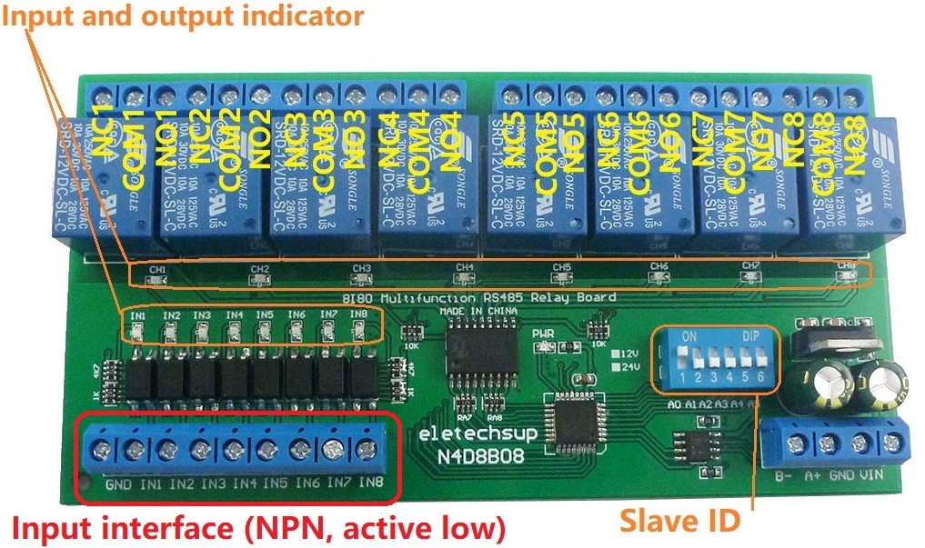

**Features:**

1: DC 12V (12V Version), DC 24V (24V Version)

2: Standby current (all relays closed) 13MA, 1 relay open 41MA, 2 relays open 69MA, 3 relays open 95MA,4 relays open 122MA,5 relays open 149MA,6 relays open 174MA, 7 relays open 198MA,8 relays open 225MA

3 8 photoelectric isolation Input ports (NPN low level active ), the input and output relationship can be set to associated (default) and non-associated through commands.

4: "open" "close" "Momentary" "Self-locking" "Interlock" "Delay" 6 Commands

5: MODBUS RTU command, Support 03 06 16 function code

6: Under the "Delay" command ,the maximum delay is 255 seconds;

7 MODBUS commands can be made serial HyperTerminal (serial assistant) OR "Modbus Poll" Enter;

8 Under the MODBUS command mode, it can support up to 64 devices in parallel

9 The default baud rate is 9600BPS. The baud rate can be selected through jumpers: 2400 4800 9600 19200BPS

10 Size: 136 * 72 * 20mm(Only PCB Board);140 * 88* 42mm(with Din Rail Box)

11 Weight: 134g(Only PCB Board);223g(with Din Rail Box)

12 Maximum load: 10A / 250VAC, 10A / 125VAC, 10A / 30VDC, 10A / 28VDC, 10A / 12VDC

DIN rail Box parameters:

Product model: UM72

Color: green

Width: suitable for PCB board width UM72(72mm)

Insulation grade: flame-retardant VO grade

Backplane length: suitable for 136 mm PCB boards

Net weight: 99g

Installation: DIN35 and C45 rail

**Glossary:**

NO : Relay normally open contact

COM : Relay common contact

NC : Relay normally closed contact

Open : NO connection COM, NC disconnect COM

Close : NO disconnect COM, NC connection COM

Momentary : Enter the Momentary command, the Rreceiver Relay is Open, delay of 0.5 seconds after, Relay is Close;

Toggle : Enter the Toggle command, the Rreceiver Relay is Open, Enter the Toggle command again, Relay is Close;

Latched : Enter the Channel 1 Latched command, the receiver Channel 1 is Open, the Channel 2 is Close.

Enter the Channel 2 Latched command the receiver Channel 2 is Open, the Channel 1 is Close.

Enter the Channel 3 Latched command the receiver Channel 1 is Close, the Channel 2 is Close.

Delay : Enter the Delay command, the Rreceiver Relay is Open, delay of 0-9999 seconds(MODBUS command is 0-255 seconds )after, Relay is Close;

During the delay, Eter the Close command, immediately close the relay

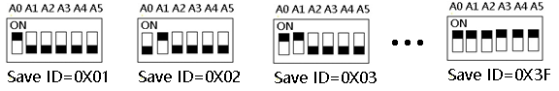

Slave ID: A0-A5 is the slave ID, you can choose 64 different slave ID.

Under the MODBUS command mode,the slave ID must be correct

command Description, Please refer to "N4D8B08 8-channel RS485 IO input and output controller commamd"

**Typical applications:**

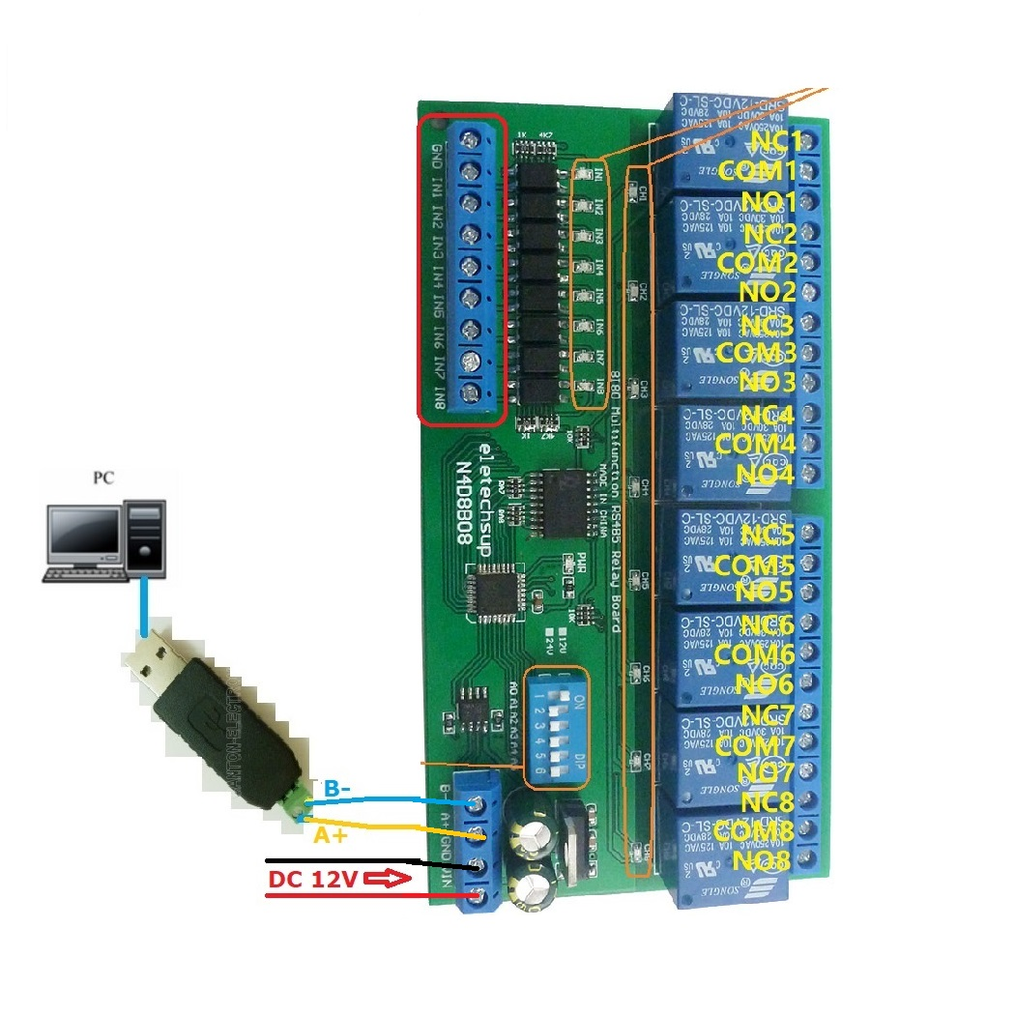

1 The dial switch (slave address) is invalid and can only control one module at a time.

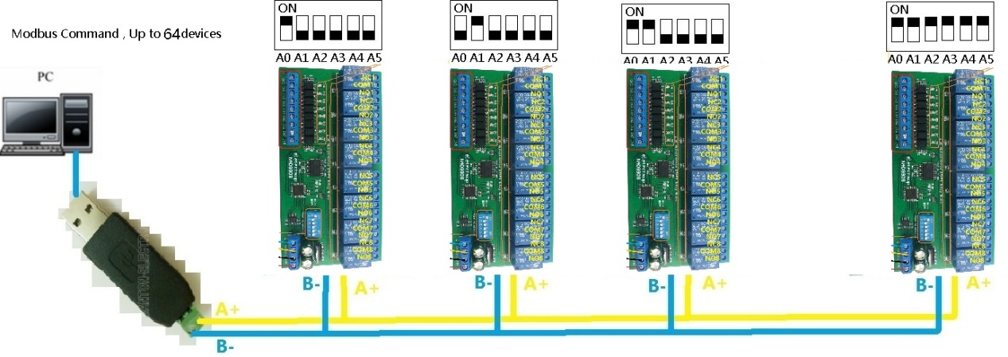

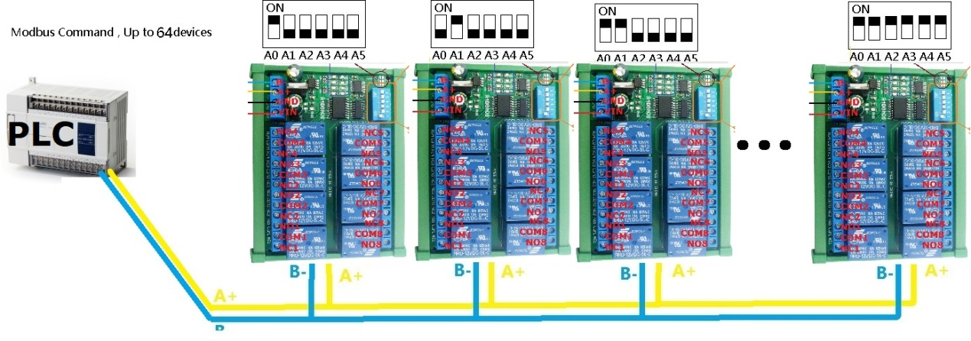

MODBUS command mode (HEX), you can control a variety of ways: Serial Hyper Terminal Control (need to manually add the CRC), Modbus Poll software control (software automatically add the CRC), PLC or MCU process control

**Wiring Diagram:**

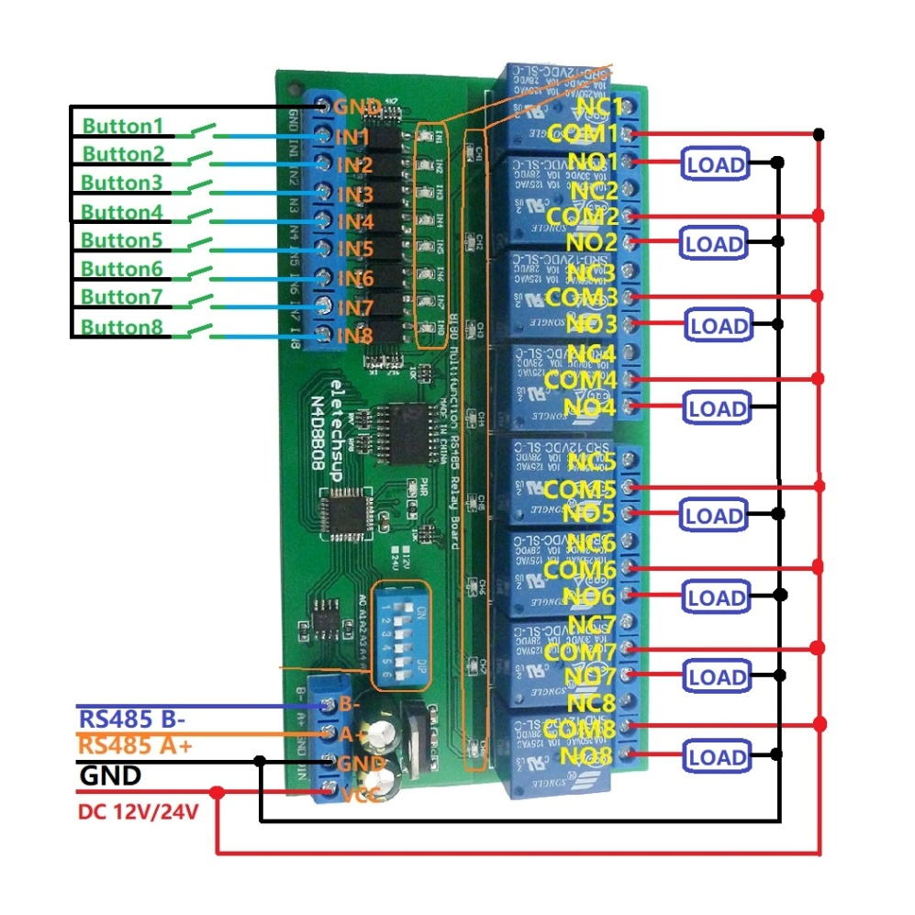

1 DC 12V control circuit,Wiring diagram below. "LOAD" may be camera,LED lights, fans, motors and other DC 12V equipment

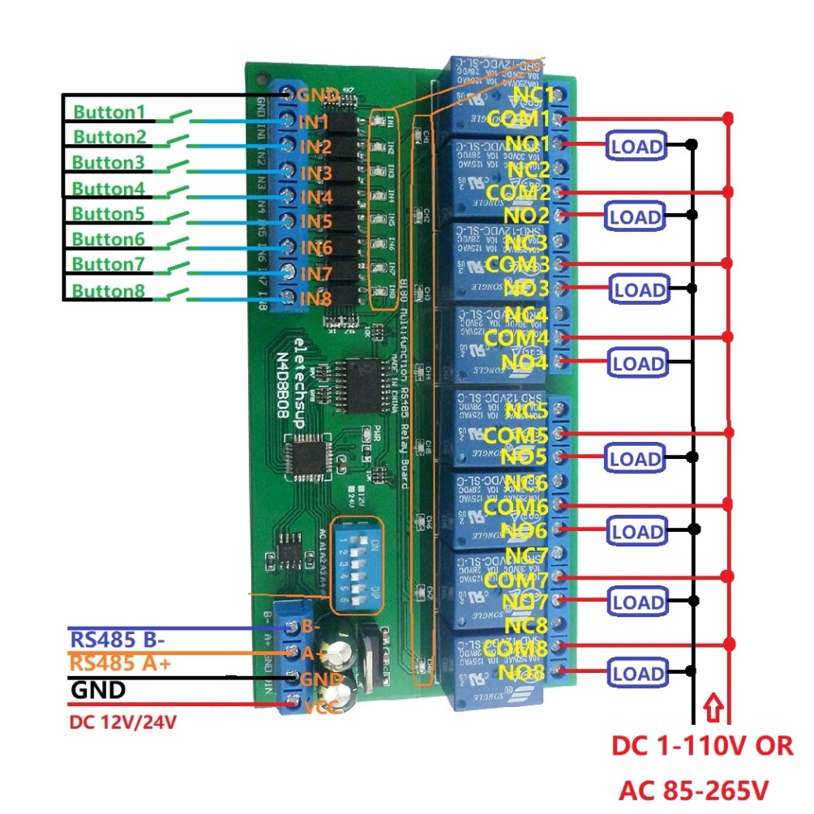

2 DC 1-110VAC 85-265V control circuit,Wiring diagram below(Note:If not DC 12V load, need another DC 12V power supply). "LOAD" may be LED lights, fans, motors Lights, fluorescent lights, solar water heaters and other DC AC equipment

